Plants vs Zombies
Voineag Diana-Ioana
Affiliation:<Faculty of Automatic Control and Computer Engineering,Iasi>
Emai:<diana-ioana.voineag@student.tuiasi.ro>
Link GitHub: <https://github.com/DianaVV2002/PlantsVSZombies.git>
Academic year:<2022-2023>

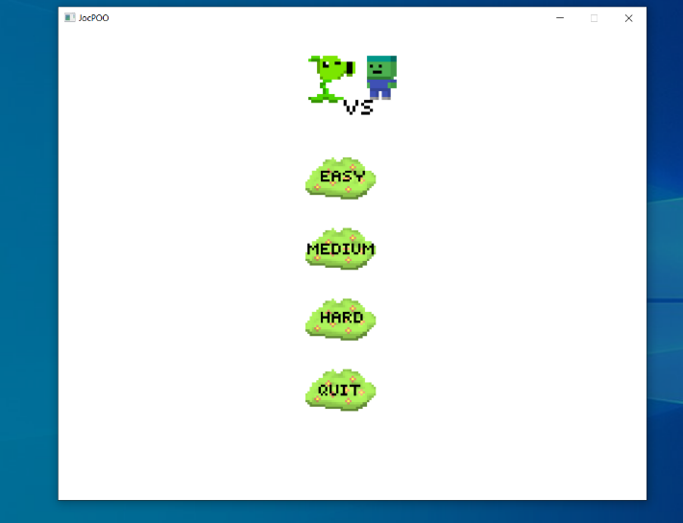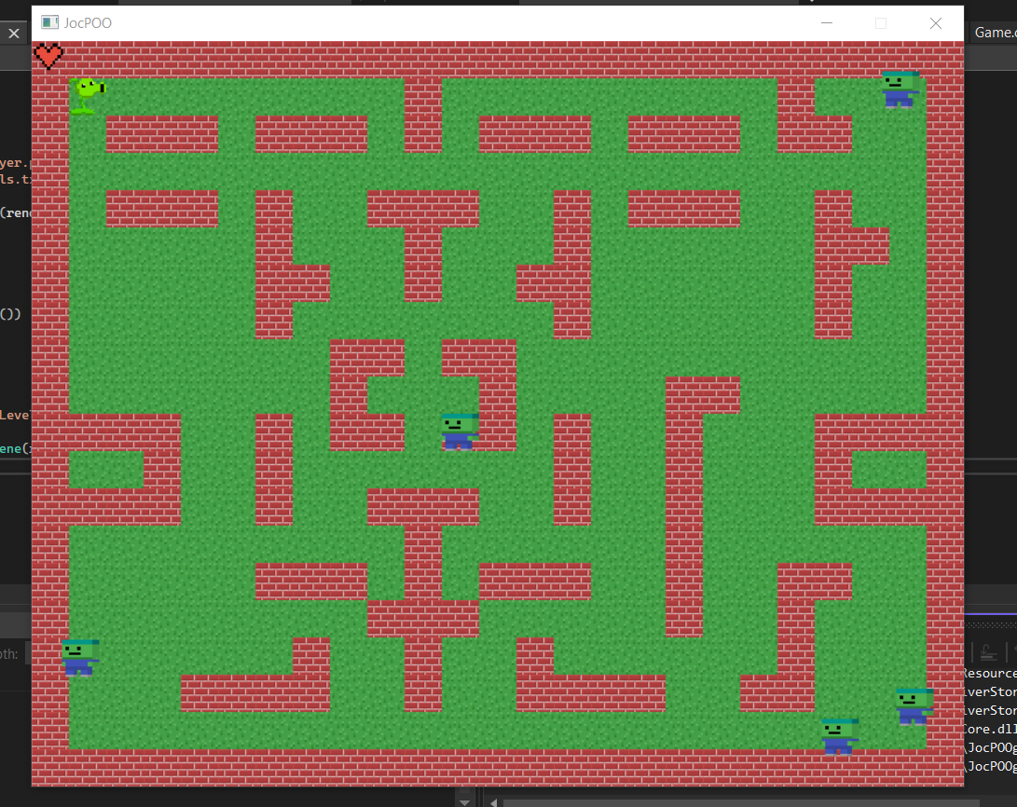
Gameplay: Single player campaigns where the player must defeat all the enemies throughout all the three levels in order to save its world.
Plot: The game is set in one beautiful garden somewhere in an exotic country. Our plant was just looking for his friends as they seemed to have disappeared overnight. However, in his journey our plant discovers that the garden was attacked by zombies after some sort of apocalypse he didn’t know of. Unarmed and alone, he must face and defeat all the enemies to protect the garden. He soon discovers that bees make wonderful bullets against his enemies and make a pact with them to save the world.
Characters:
1) The plant is the protagonist and player-character. He looks innocent, but his bees will save the world one day.
2) The normal zombies are the enemy, but they are very dumb and are easy to be defeated. They come in packs and the more zombies there are the more powerful they get.
3) One final bee zombie portrays pure evil. After he died in unknown conditions he chooses to seek revenge and go against our hero.
Mechanics:
Use the arrows on the keyboard to move the plant character and give direction to the bees(bullets). You can fire a bullet with the space key and the bullet will follow the direction of your character. One bullet kills a zombie, only the final bee zombie requires 3 bullets to be killed.
Our character has 3 lives displayed in the left corner of the game screen and every time a zombie touches him he loses a life.

